Branch Prediction Testcase

Times of end cycles

* with forwarding only: 16900
* without forwarding & hazard detection & flushing: 23300
* with all units working: 13700
* with forwarding and hazard detection: 16900

Waveforms:

1. with forwarding only

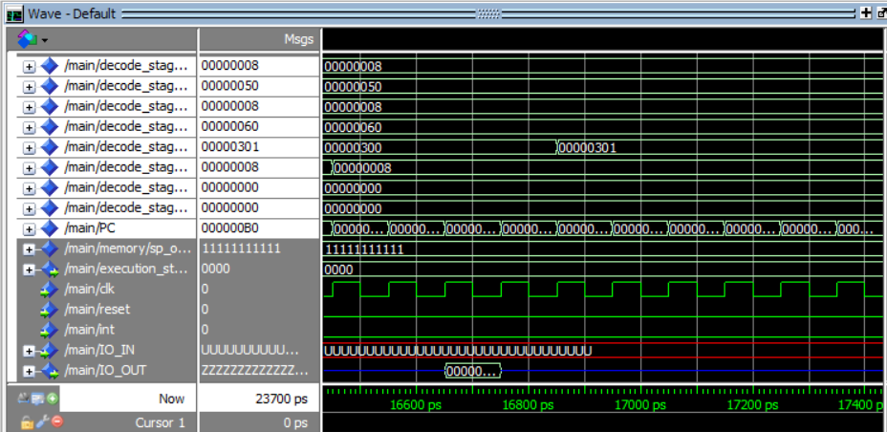

1. without forwarding & hazard detection & flushing

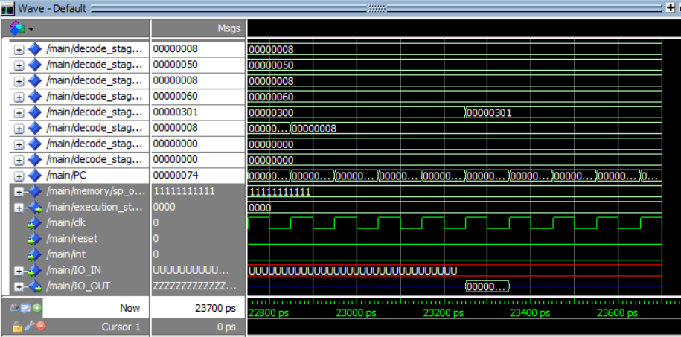

1. with all units working

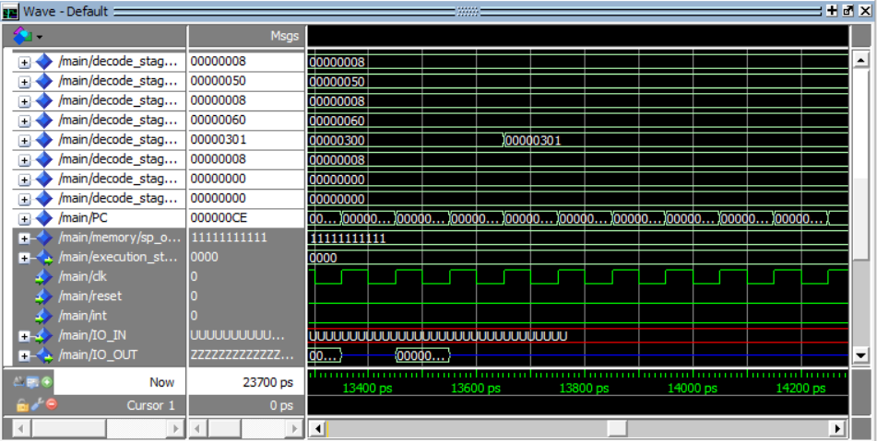

1. with forwarding and hazard detection

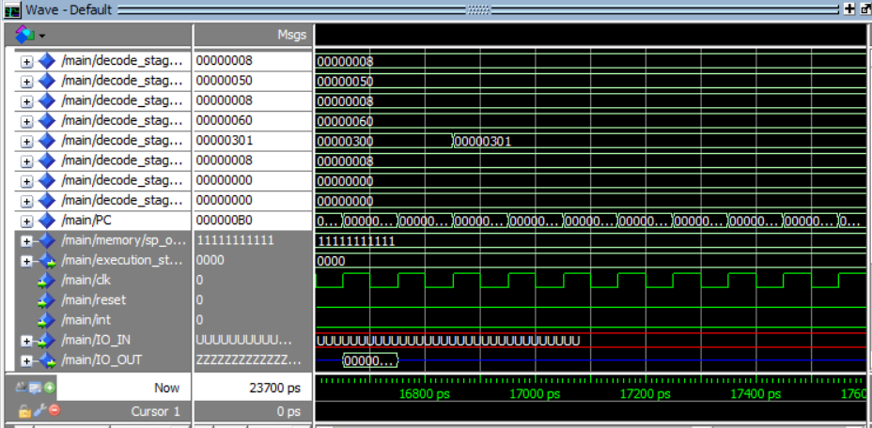

Comments:

1. No data hazard with forwarding because ldm loads imm values not from memory so the forwarding unit will forward it.
2. Both with forwarding only and with forwarding and hazard detection got the same number of cycles needed to finish because in this file forwarding unit made that there’s no data hazards at all.

Hazards happened:

* Disabling flushing and always predict not taken caused control hazard after each jmp/jz/call instructions and to solve it we added 2 NOPs after each of them

Instructions got the hazard:

JMP R3

JZ R1

JMP R3

JMP R3

JZ R3

Check the testcase analysis code

* Disabling hazard detection unit caused no hazards
* Disabling both hazard detection unit and forwarding caused data hazards and to solve it we added NOPs before each instruction causing hazard to make sure that while it’s in decode stage the data are ready in write back stage

|  |  |
| --- | --- |
| Instructions got the hazards | Number of NOPs needed before it |
| JMP R3 | 1 |
| OUT R4 | 2 |
| JMP R3 | 1 |
| OUT R4 | 2 |
| AND R0,R2,R5 | 2 |
| OUT R4 | 2 |